

Faculty name: INFORMATION and COMMUNICATIOn TECHNOLOGY

PROG103: OBJECT ORIENTED PROGRAMMING 1
Title : Back-End
Issue Date : WEEK 2
Due Date : WEEK 4
Lecturer/Examiner : Mr. Aiah Jamaes
Name of Student/s : Mustapha Kamara
Student ID No. : 905001054
Class : BITF 2102
Semester/Year : 1 of 2

Academic Honesty Policy Statement
I/We, hereby attest that contents of this attachment are my own work. Referenced works, articles, art, programs, papers or parts thereof are acknowledged at the end of this paper. This includes data excerpted from CD-ROMs, the Internet, other private networks, and other people’s disk of the computer system.

Student’s Signature : Date:

LECTURER’S COMMMENTS/GRADE: | for office use only upon receive  Remark  DATE :  TIME :  RECEIVER’S NAME :

Q1 A. Steps to follow when planning a Visual Basic application
- Understanding the problem
- Design application
- Code the application
- Test the application
B. The difference between an ‘object’s text property’ and its ‘name property’ is that, the object’s name property is used to rename the labels or the displays on the form for directional purpose on the form, whilst the name property is used to identify or refer to the textbox in code. Example,
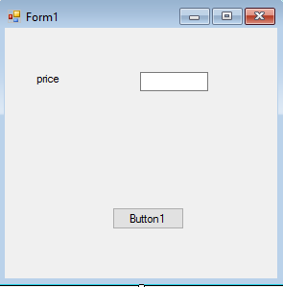

Object text property name property
(price) (txtprice)

C. Visual Basic instructions to follow when performing the following:
- changing the red label’s font to the font selected on the font dialog control.
- Select the text
- Go to property window, ‘Appearance’
- Click on the ‘Font’
- Adjacent to ‘font’, the default font is ‘Microsoft Sans Serif, 8.25pt’ .
- Click the little box with the 3 dots inside
- The dialog control box will appear and you can select your choice of font

- Specifying that the PrintForm1 control sends a printout of the interface directly to the printer
- Open the toolbox
- Double click on the button, and it will appear on the form
- Go to the property window
- On the object’s text property, you change the default name of the button to the function of the button and also change its name. In this case, it could be ’PrintForm1’ as the object’s text property and ‘btnprintform1’ as it name. The can then be written for the button to send to print when click.
- Changing the label text to red
- Go to the property window
- Appearance and font
- Click on and adjacent tab to ‘font’ that labels ‘control text’ dropdown arrow
- A dropdown list will appear
- Select custom and select the color red

D. The flowchart that corresponds to the pseudocode
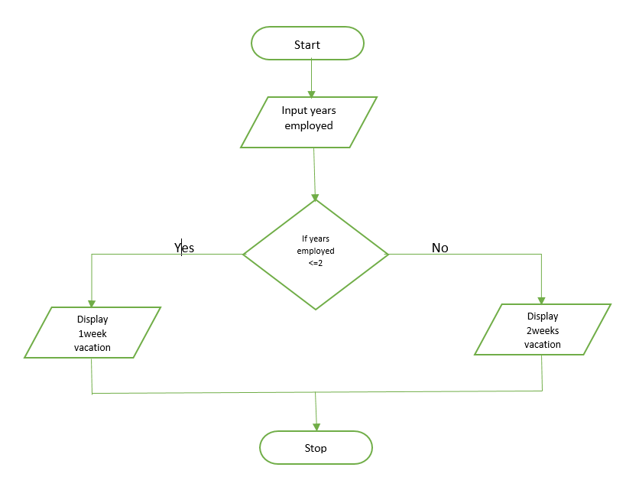

E. Dim statement that declares an integer variable and initializes the variable to the number 1.
Dim counter As Integer = 1
Q2 A. statement to perform the following task:
Dim sales As Double
Const bonusRate As Double
Dim result As Double

result = bunusRate
B. A procedure-level TaxRate constant whose data type and value are Double and .09 respectively.
Const TaxRate As Double = .09
C.
Private Sub btncalculate_Click(sender As Object, e As EventArgs) Handles btncalculate.Click
Dim total As Integer
totalLabel = txttotal.Text

D.
Const CommRate As Decimal = .12

E.
Private Sub btncalculate_Click(sender As Object, e As EventArgs) Handles btncalculate.Click

Dim westSales As Decimal
Dim eastSales As Decimal
Dim totalSales As String
westSales = txtwestSales.Text
eastSales = txteastSales.Text
totalLable = txttotalSales.Text

totalSales = westSales + eastSales
totalLabel.Text = Convert.ToString(“totalSales”)

